Dijkstra's algorithm :-
Dijkstra's algorithm is used to find the shortest path between the two mentioned vertices of a graph by applying the Greedy Algorithm as the basis of principle. Dijkstra's algorithm can be used to find the shortest route between one city and all other cities. It does not work on graph with negative weights (or edges).The time complexity of Dijkstra's Algorithm is typically O(V²).
Applications of Dijkstra’s Algorithm :-
1. Network routing protocols.
2. Route Planning in transportation network.
3. Communication routing in telecommunication networks.
4. Path finding in video games.

Example 1:- (Non Greedy able)
Source = A ; Destination = F
2 2
A B C
2 2
F E D
2 2
Conclusion :-
B=2
C=4
D=6
E=8
F=10

Example 2:- (Greedy able)
Source = A ; Destination = F
2 2
A B C
2 2
F E D
2 2
Conclusion :-
B = 2
C = 4
D = 6
E = 8
F = 2

Example :-
Consider a weighted graph, G and a source vertex, P.
This algorithm will find the shortest path from P to all other
vertices.
1 A 10
P 2 C
4 B 4
Source = P

Vertex ^{DP}
Visted/Explored | Unvisited/Unexplored
 | P⁰ A∞ B∞ C∞
P⁰ | A^{1P} B^{4P} C∞
P⁰ A^{1P} | B^{3A} C^{11A}
P⁰ A^{1P} B^{3A} | C^{7B}
P⁰ A^{1P} B^{3A} C^{7B}
Conclusion:-
Shortest path From P to other vertices :-
A = 1
B = 3
C = 7

Example 2 :-
Consider a weighted graph, G and a source vertex, a, the algorithm finds the shortest path from a to all other vertices.
Source = a
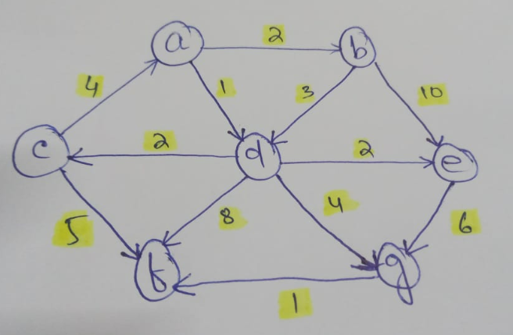

Explored | Unexplored
 | a⁰ b∞ c∞ d∞ e∞ f∞ g∞
a⁰ | b^{2a} c∞ d^{1a} e∞ f∞ g∞
a⁰ d^{1a} | b^{2a} c^{3d} e^{3d} f ^{9d} g^{5d}
a⁰ d^{1a} b^{2a} | c^{3d} e^{3d} f^{9d} g^{5d}
a⁰ d^{1a} b^{2a} c^{3d} | e^{3d} f^{8c} g^{5d}
a⁰ d^{1a} b^{2a} c^{3d} e^{3d} | f^{8c} g^{5d}
a⁰d^{1a} b^{2a} c^{3d} e^{3d} g^{5d} | f^{6g}
a⁰d^{1a} b^{2a} c^{3d} e^{3d} g^{5d} f^{6g}

Shortest path From a to other vertices :-
b = 2
c = 3
d = 1
e = 3
f = 6
g = 5

